Introduction
Through my studies, time spent attending different tech-focused conferences, and my professional experience as a front-end developer, I have come to recognize that those who work closely with data and retain organizational or ‘domain’ knowledge are those who are harder to replace within an organization. It is this mindset that I brought into this project, where I wanted to focus not just developing a database schema, but managing, transforming, and organizing data into a clear, understandable, flexible, and easy-to-manage data layer that can be utilized by any application — from a mobile app to a web application.
One such application that I have done some frontend work on, but so far have no meaningful data layer, I call “Explore More.” Up to this point it is a web application that I want to build focused on collecting and sharing information about state, county, and national parks that is more reliable than Google Maps and can help those who simply want to ‘explore more’ of their state.
Beyond the need to create a good data layer for this project, I also chose it because I love being outdoors but find it hard at times to find any good source that tracks and manages information about state and national parks in one place. For example, if you want to explore Minnesota you may start with the MN DNR State Parks website, which is great for those who want to step out of the city for a weekend. However, what about wanting to learn more about the state’s state and national forests, national park managed properties, or even county parks? Each are managed and shared through different websites. Google is sub-par for collecting this information into one place, and I — as well as others I have talked to — agree that Google is not a solve-all solution for this.
From my description for this project, one can assume that the sky is the limit… and it is! I have ambitious plans for this project that I’ll continue working on it even after the conclusion of this class. However, to keep myself on track for this class I have defined some minimal and optimistic goals.
Minimal Goal
For my minimal goals within this project, I focused on developing just the data layer for my explore more project. Specifically, I wanted to focus on how I would collect and manage data from multiple sources and learn how to properly transform the data into one normalized source. The technologies that I chose to work with include Python for scripting and DuckDB for managing the data. The outcome goal is to have a set of Python and SQL scripts that would successfully allow me to import and transform data from multiple sources into one normalized database schema. Specifically, data that represents US National Parks, Minnesota State Parks and some campgrounds that are federally managed.
Optimistic Goal
My optimistic goal for this project is to build on top of my minimal goals by creating a mini demo web application where the DuckDB data is migrated into a PostgreSQL database with the PostGIS extension for geospatial data installed. The front end would utilize React as a mapping UI with a similar feel to Google Maps. The backend would be a simple Django/Python API layer that would serve the data from the database to the frontend, following the pattern that we discussed in class where data doesn’t travel directly from the database to the client (aka web browser or mobile app).
Exploring

Prior Database Experience
Prior to this course, I did have some experience with databases. Not only did I take an undergraduate database course during my time at St. Thomas (primarily using MySQL), but I also interacted with databases at work in the role outlined in our textbook as a programmer — mainly writing SELECT and occasionally UPDATE or ALTER TABLE queries to help manage the database and fix bugs that come up during application use. After graduating from St. Thomas, I also have done some personal projects that allowed me to experiment with SQLite, PostgreSQL, and Microsoft SQL. Where I lack database experience is in database administration and data normalization techniques, which is what brought me to this class.

Initial Ideas Considered
There were a few project ideas that I was mulling over before deciding which include:
- Create a database to track and manage Disney property entities like attractions, restaurants, and shows. I was also thinking of expanding this project to create an application that would allow users to journal and log which Disney experiences, restaurants and shows they have experienced on their visit. I would find this extremely useful for my nearly biennial trips to Disney World.
- Build the data layer for a developer documentation tool that would allow developers to describe and understand their database schemas across different database platforms (Oracle, Microsoft SQL, SQLite, etc.), similar to how column comments work in PostgreSQL but more universal. Essentially, bringing the documentation closer to the database.
- Design the data layer for a branch management system, where an organization could set up branches managed by a parent organization — similar to how bank branches are managed by a regional hub which in turn can be managed by a parent bank branch.
- Build the data layer for my “Explore More” application, focused on aggregating park and recreation location data from multiple public sources into one normalized schema.
Ultimately, I chose the Explore More data layer project because I believe it allowed me to encompass more aspects from what I learned throughout this semester in this database course. Including but not limited to structuring a normalized database schema through ER diagrams, learning and building advanced SQL queries and views, and understanding on a more detailed level how SQL can be used in different instances to transform data for project requirements.

Sources Used in Choosing the Project
Most of my initial direction while researching and deciding on a topic was influenced by personal experiences as well as with conversations with colleagues at work, family and friends who share similar and conflicting experiences. I ultimately decided on the Explore More project due to learning in a couple of articles how organizations like Salesforce have issues with properly transforming data out of one system into another successfully (Rolli, Veeraraghavan). Other research focused on my interest in Geospatial data management in different databases and how DuckDB and PostgreSQL are different and solve different user requirements (Digitalogy, MotherDuck, Geodata Insights, Map Library).
Building
What was built for this project is the foundation of a data processing pipeline that focuses on collecting and combining data from multiple different sources into one unified schema that can be used by any kind of application. The minimal viable goal was to create this pipeline and to be able to present views and queries showing the real collected and normalized data.
Data Sources
There were five data sources chosen for this project:
- National Park Service (NPS) API — Publicly accessible (up to 1,000 requests/day), this API provides park descriptions, operating hours, contact information, addresses, activities, entrance fees and campground information for all NPS-managed lands and properties across the United States. (nps.gov/subjects/developer)
- Google Places API — Accessible through Google Cloud with up to 1,000 free requests per month. Used to retrieve location-level detail for Minnesota State Forests, County Parks, State Parks, and City Parks.
- MN Geospatial Commons — Managed by the State of Minnesota, this source provided the State Parks, Recreation Areas and Waysides dataset in shapefile format — a geospatial vector data format used in GIS software. (gisdata.mn.gov)
- Recreation.gov (RIDB) — A dataset representing campgrounds and recreation areas managed by federal agencies across the United States, provided as downloadable CSV files. (ridb.recreation.gov/download)
- MN DNR Park and Trail Guide — A map published and updated annually by the Minnesota DNR that outlines attribute-based information for every State Park and Recreational Area in Minnesota. (2025 PDF)
Data Collection Pipeline
To get all the data imported into a DuckDB database for analysis and transformation, I created a Python script for each source, all managed by a single orchestrator script. The orchestrator script can be run from a command line shell and utilizes flags that are established per source to make it easy to run individual loaders during testing or needing to re-import the information. This approach kept the iterative process of testing, reviewing output and fixing issues manageable. When this iterative process was complete, I simply ran the orchestrator script with the ‘--all’ flag to import all sources successfully into one single DuckDB database. For transparency purposes AI was used to create about 60% of these Python scripts.
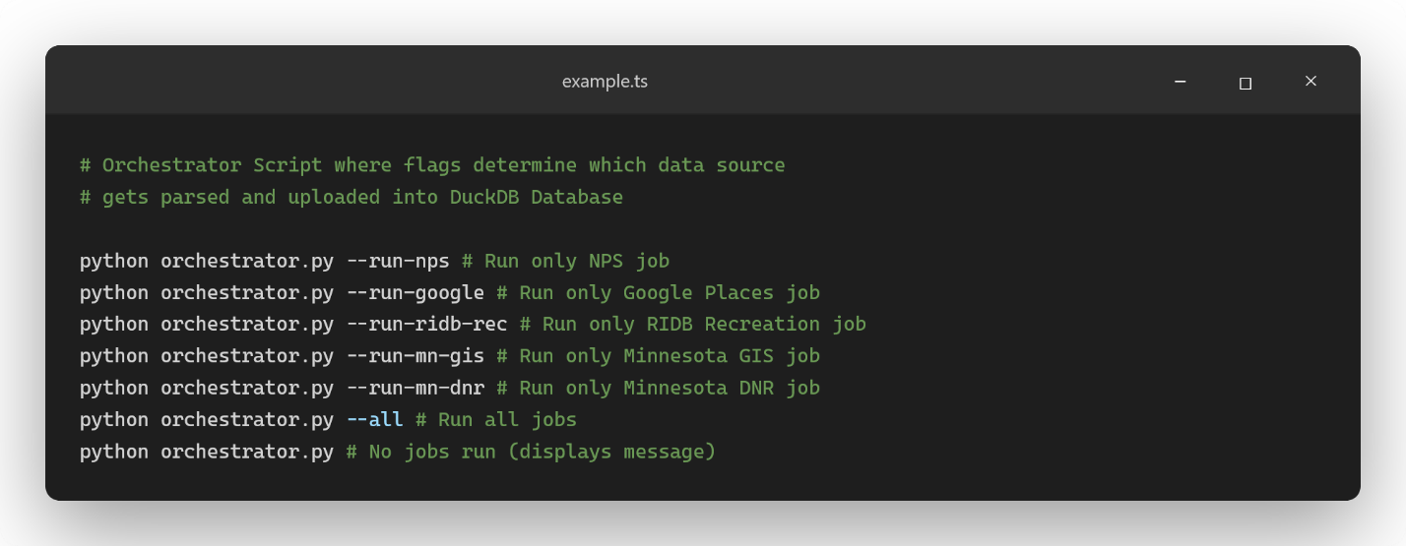
Python commands to run in Shell Command Line to start data importing process
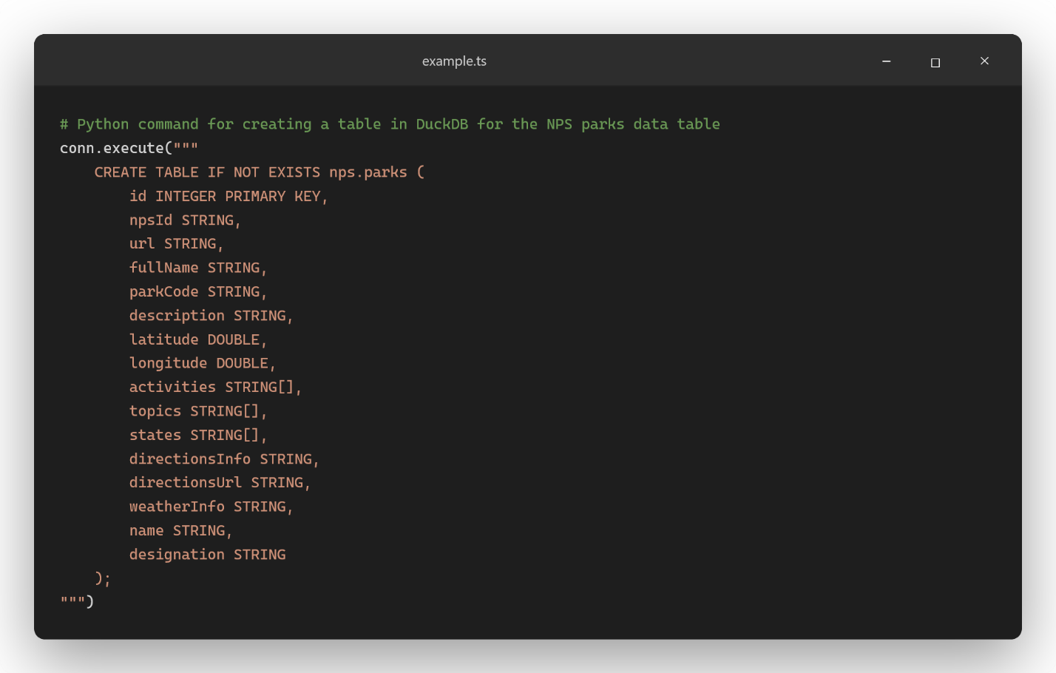
Python script code exemplifies how to create a DuckDB table under the nps schema namespace
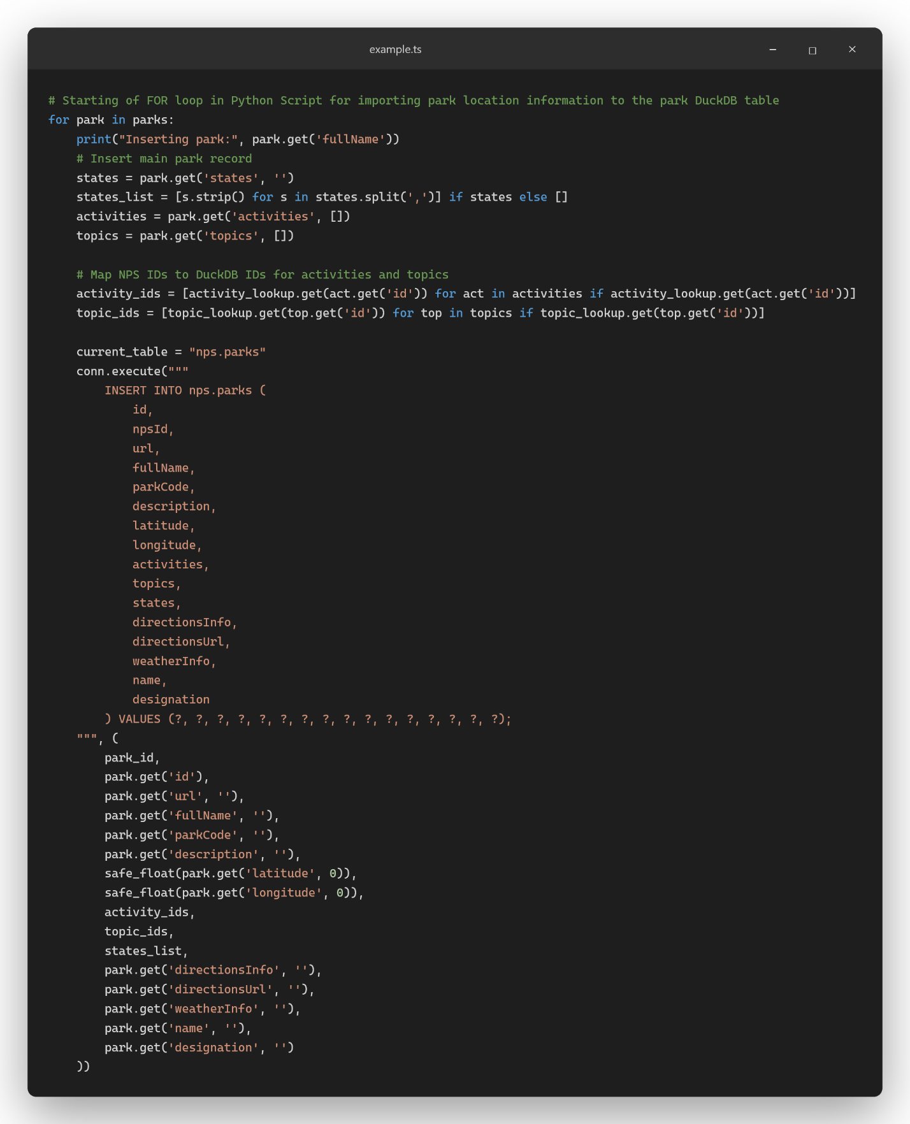
Python script example of inserting extracted data from source into DuckDB database nps namespace parks table
One DuckDB concept that is important to note here is DuckDB’s SCHEMA feature. This feature allowed me the ability to organize data from all different sources into individual namespaces. These namespaces are essentially a container “that defines how data is organized within a database” (Schema). I specifically utilized this to have a namespace created for each data source to help reduce the cognitive load of managing many different tables and views that quite possibly could have naming overlap between different sources. Then to query and create tables in each SCHEMA namespace all I needed to add to my queries was the namespace name followed by a period before the table name. For the most part it is managed within my Python scripts where towards the top of each script there is the needed SQL in place to create a SCHEMA namespace in the database. Then all following CREATE table queries within the same script use that defined namespace.
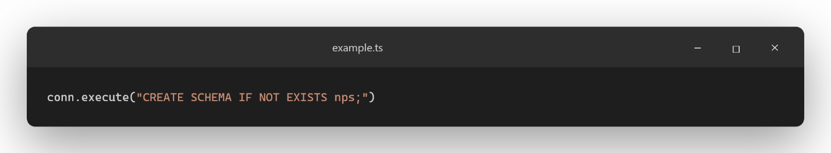
Python script snapshot showing how to create a DuckDB SCHEMA namespace
After the scripts run, I then have an individual SCHEMA namespace setup for each source with the tables created and data imported. An example image below shows how the NPS data retrieved from the API lives within the nps schema, while the MN GIS data lives under the mn_gis schema. The normalized schema represents my entities that I intend to transform all the data collected into and isn’t created by a Python script but rather exists as a standalone .sql file that I would run in a Database Management System (DBMS) software like DBeaver.
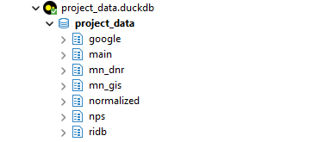
DuckDB Database structure view within DBeaver DBMS

Normalized Database Design
Once all data was imported and organized into the source-specific SCHEMA namespaces within DuckDB, the next step was to create a normalized database schema to transform all the source data into. Before writing any SQL code for this normalized database schema, I used Oracle’s SQL Data Modeler tool to design a comprehensive, intuitive, and normalized database managing the following entities: Locations, Operating Hours, Operating Hours Times, Media, Phone Numbers, Email Addresses, Addresses and Websites, some with their own corresponding type tables.
Data Modeling – Logical and Relational ER Diagrams
Textbook Reference: Chapter 5; Understanding Entity Relationship Diagrams
Logical Model
The logical model outlines all the planned entities, their attributes, and the relationships between them. The key design decisions that I included while crafting the logical model include:
- The Locations entity has a self-referencing relationship, enabling easy to establish and query hierarchical location structures where campground locations can be classified as children of state parks, national parks and other parent locations. This relationship is one-to-many optional, meaning a location may or may not have a parent or a child but a given parent location can be associated with many children locations.
- Data Source and Location Type entities are required associations for any location record. Meaning that a location cannot exist without both a data source and location type. However, both types can exist without any locations assigned to them.
- Websites, Addresses, Media, Phone Numbers, Email Addresses, and Operating Hours entities, all have a one-to-many relationship with the Locations entity. Each of these entities must belong to exactly one location, but a single location can have zero to many of each of these entities.
- Type tables for Websites, Addresses, and Media allow for deduplication of repeated type labels across potentially hundreds of thousands of potential records, directly reducing data redundancy
- The Operating Hours Time table that associates to the Operating Hours entity stores individual day-level time records. This is more structured and queryable than storing a JSON column per day on the Operating Hours table directly.
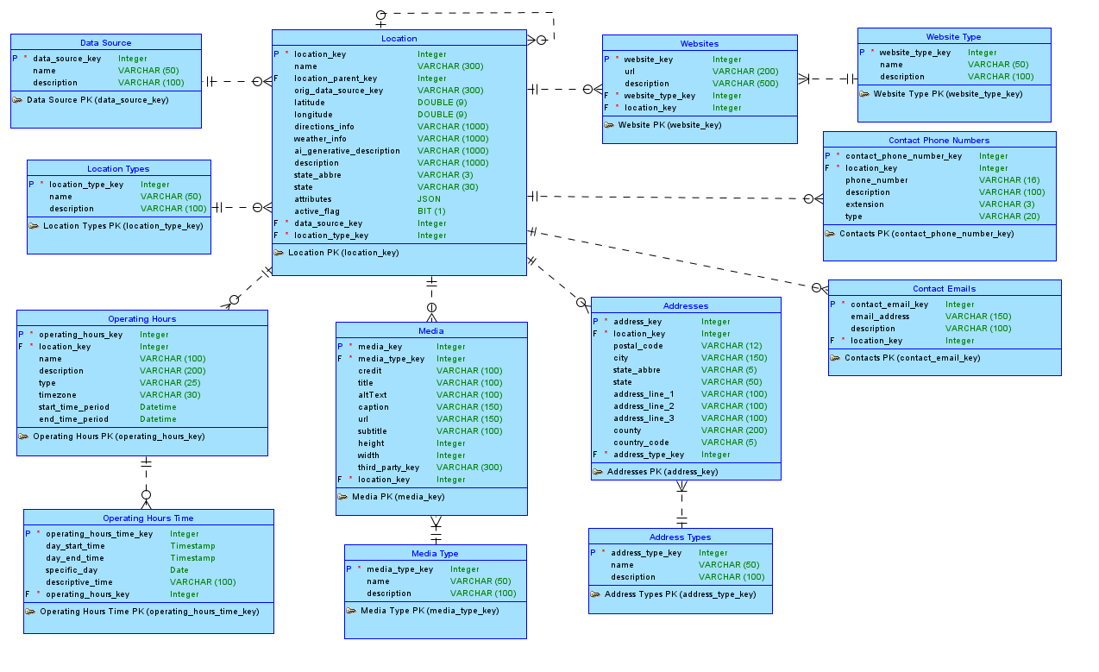
Logical model of normalized DuckDB database schema created to transform data from sources into
Relational Model
The generated relational model shows that all the relationships established in the logical model were at the most one-to-many, which does not generate any connecting or junction tables. Foreign keys and foreign key constraint classifiers are also visible within the relational ER Diagram. In all its glory, this relational model was used as the exact design to code up the normalized DuckDB DDL code that exists in the DuckDB SQL Queries - Create Normalized Tables.sql file within the GitHub repository that is referenced in this document.
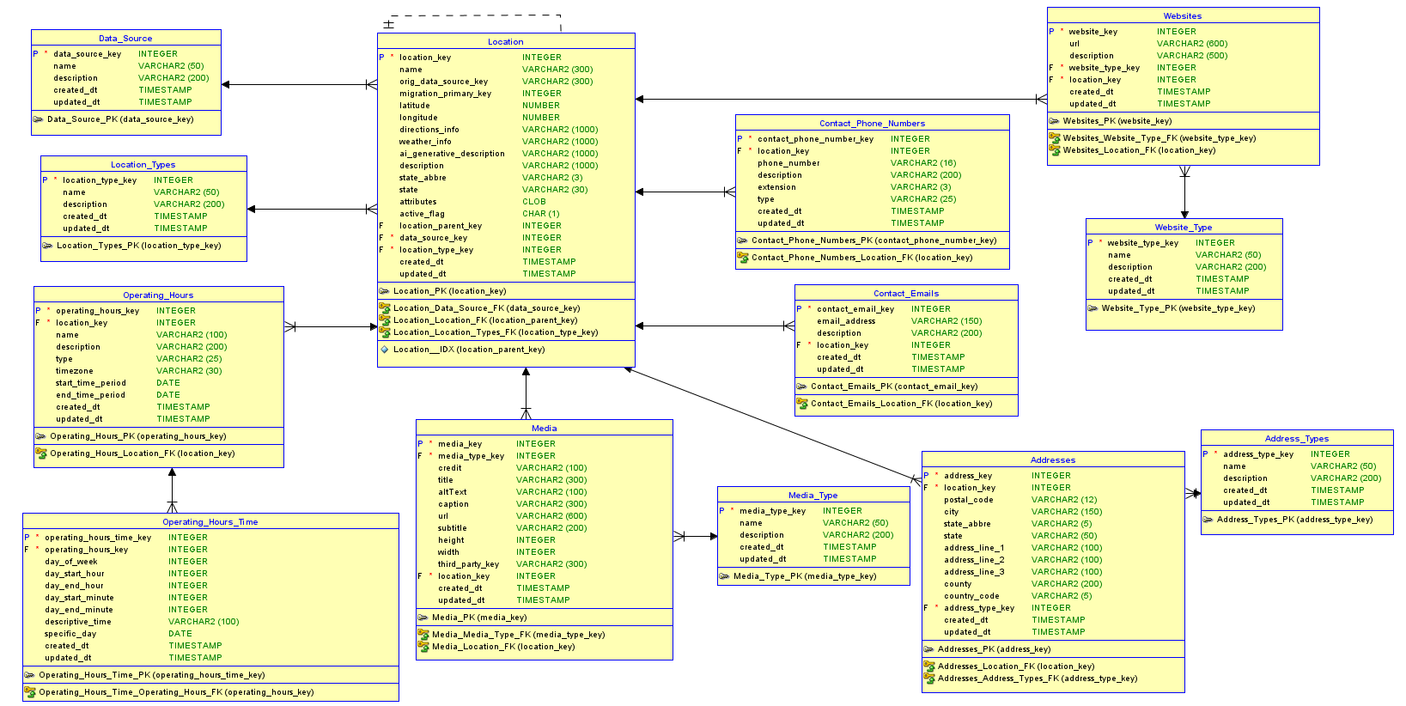
Relational model of normalized DuckDB database schema created to transform data from sources into.

DDL: Creating the Normalized Schema

Database Normalization – Creating the Normalized Schema
Textbook Reference: Chapter 7; Normalization Concepts and Processes
Most of the five data sources (except for the RIDB CSV source) arrived in a denormalized or inconsistently structured format. The NPS API returns nested JSON with operating hours, and other information embedded inside location objects. Another example is how the MN GIS shapefile combines geographic and attribute data into a single record per park.
The normalized schema created for this project addresses this by decomposing repeated data into type tables (WebsiteType, AddressType, and MediaType), separating contact information into dedicated entities and representing operating hours at a day-level granularity through the OperatingHoursTime child table. This design targets Third Normal Form (3NF), where each non-key attribute is functionally dependent only on the primary key and there are no transitive dependencies.
Project Specific Needs – Working against normalization
Textbook Reference: Chapter 6; Developing Data Models for Business Databases
However, one notable outlier that I highlight is the aspect that the location entity still stores state related data. Based on the structure of these entities and aligning with 3NF it would be proper to ensure that the state information only exists in the address entity. However, this wasn’t done due to some data sources not having address information available (MN GIS data source for example), but knowing where the data was found, the state can be derived. This highlights an important aspect of database creation and management. Normalization is great, however, sometimes based on the project and how the database will be used, proper normalization may work against you. In this case if I followed through with proper normalization I would have ended up with nearly entirely empty address records within the addresses table just to store state information about a given location which results in wasted space and the need for more complex JOIN table queries to resolve what state locations are located in.
This ties directly into what was discussed in chapter 6 when it comes to identifying business constraints and relationships between entities and what was mentioned in class when the following quote was discussed:
“Normalize until it hurts than denormalize until it works.”
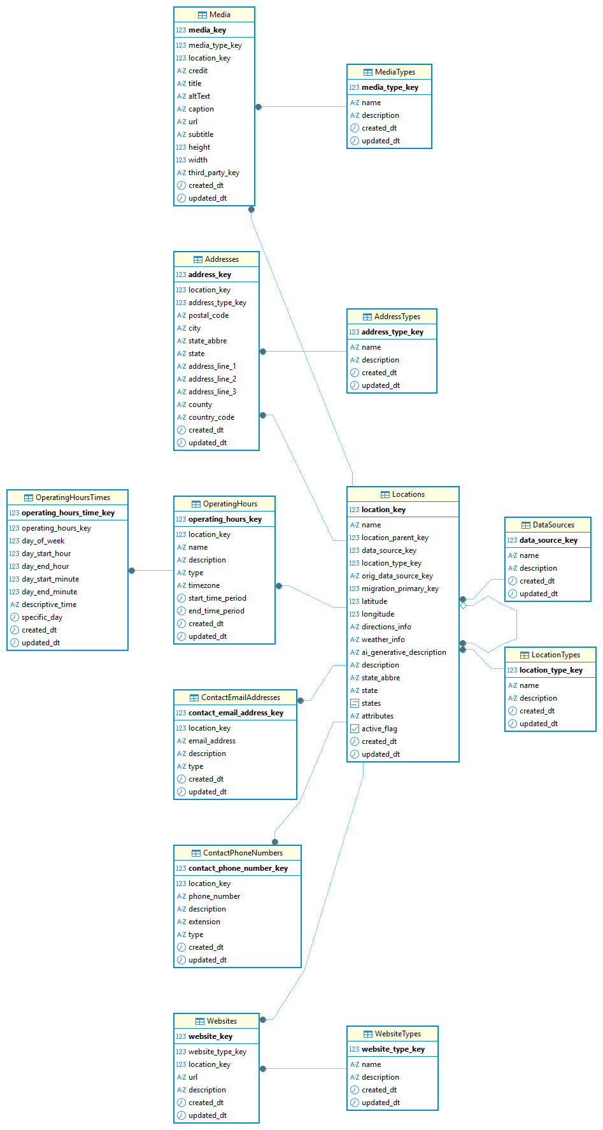
Normalized schema diagram generated in DBeaver DBMS from the “normalized” schema in the DuckDB database

Data Transformation: Views and INSERT Queries
Database Views – Transforming Data Sources
Textbook Reference: Chapter 10; Views, Null Values, and Hierarchical Queries
The final step was to transform the raw source data into the normalized schema. Rather than using Python for this step, individual SQL views were created within each source’s schema namespace. These views allowed me to reshape the data from its source into the structure that nearly mirrors the normalized tables that were created in the previous steps. These views were then used in conjunction with INSERT queries to move the data from each of the source namespaces into the final normalized set of tables in a new SCHEMA namespace that I named as normalized.
Using views for this step rather than inline queries or Python scripts provided many benefits. First, views are reusable and testable independently which allowed me to iteratively build and test to ensure that the proper and correctly structured data is retrieved and structured from each of the source’s table(s). Secondly, in conjunction with helping construct the proper normalized structure these views allow the encapsulation of all data transformation logic from the INSERT queries. If these views weren’t created, each INSERT query would have a huge SELECT statement that would be hard to debug. These kinds of SQL queries from my professional and personal experience can cause confusion and worry when it comes time to change or refactor the code. For each data source, there was one SQL file created, each containing the transformation views and the INSERT…SELECT view statements that populate the normalized schema from them. To be transparent, about 40% of the SQL code in these files were generated by AI. These files can be found within the duckdb-ingestion/SQL Scripts directory within the GitHub repository that is referenced in this document.
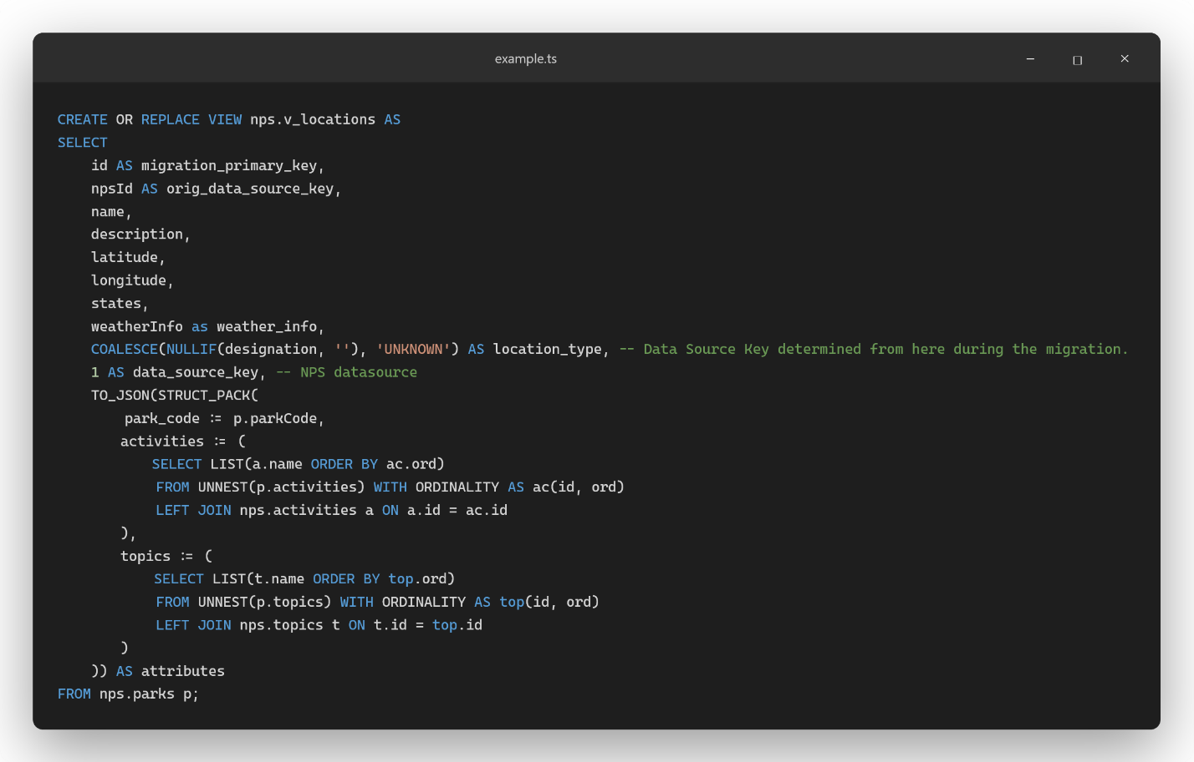
View created to transform NPS location information collected from API into expected normalized structure | The activities and topics are getting the correct data from the normalized activities and topics tables and storing the information as arrays within the attributes JSON structure.

Queries
Advanced and Other Queries – Hierarchical and JOIN Queries
Textbook Reference: Chapters 9 and 10; Advanced Matching Problems | Views, Null
Values and Hierarchical Queries

Hierarchical Queries
The Locations table was designed with a self-referencing parent_location_key foreign key, which creates a natural hierarchy where locations like campgrounds can be nested under a parent location such as a state park, state forest, or national park. The query shown in the image below is recursive in nature to handle full hierarchy depth. One thing to note that would be worth implementing in the future is a check to ensure that top-level parent locations cannot be assigned as a child of any of its children or grandchildren locations, since this would create a recursive loop without a terminating base case. This query was created based on the hierarchical query common table expression (CTE) approach noted in chapter 10. I went with this approach as it is supported in both PostgreSQL and DuckDB with similar syntax and behavior making it a query/view that will port over easily later.
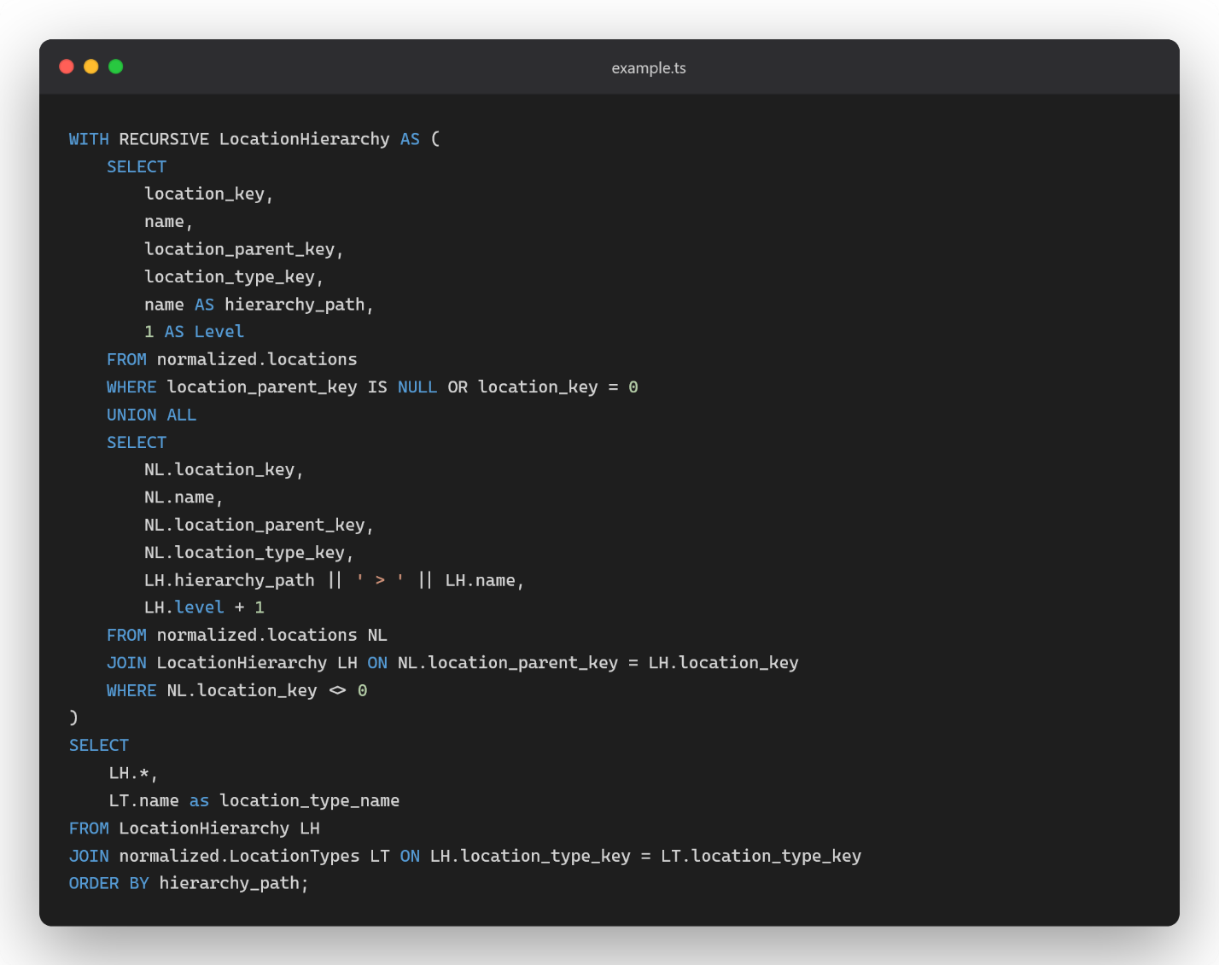
Recursive Hierarchical query created to better query and understand which locations are associated with other locations. | Extrememly useful when wanting to query for detailed inforation about a given location.

Geospatial Queries
When it comes to geospatial queries, I initially set out to try using DuckDB’s Spatial Extension, however, after some trial and error I discovered that this extension is primarily operates on planar (Cartesian) geometry and not spherical (geodesic) in nature (Spatial Extension). This distinction is important because my primary geospatial use case involves distance-based queries, such as determining which locations are within a 20-mile radius of a given point. Since my dataset is currently composed of latitude and longitude coordinates, my distance calculations require spherical geometry where I’m accounting for the Earth’s curvature. I could try to approximate these distance calculations by converting my latitude and longitude values into a planar format to be queried by DuckDB however, this would reduce accuracy. I did try this with a few AI generated queries however, the most accuracy I was able to achieve after some iterations were locations that were up to 20 miles outside the chosen radius (20- and 50-mile radiuses in my tests) returning as results of running the query. Therefore, I decided to defer further geospatial calculations until I’ve been able to migrate the data into a PostgreSQL database where in combination with the PostGIS extension, I can run more accurate and easier to craft geospatial queries based on spherical calculations.

General Join Queries
This query of the ones created in this section I would argue is the most important. In a future application, it will be important to display more detailed information about each location if the information exists. One way to collect all information is to JOIN all the tables together and organize the data in a way that a server layer can properly and easily send it to the client. In the query shown below, I structured it, so all tables are joined together, and the data is formatted in a way where each primary entity (aka. websites, addresses, contact information, etc.) all have their own column and within each column exists an already formatted JSON object that contains a list of the records that exist for each specific entity. This would allow the server layer to simply run this query and send the database response directly to the client. This format by no means is meant to be used for analysis purposes but rather application use.
One important note about this query is that I’m using LEFT JOIN on all the primary entities. This is needed because a location may not have associated records in any of the primary entity tables including websites, addresses, and contact information. If a standard JOIN was used instead (which by default is INNER JOIN), any missing relationship between the location entity and all others would cause the entire location record to be excluded from the query result. Therefore, using the LEFT JOIN approach ensures that every location is returned regardless of whether related data exists.
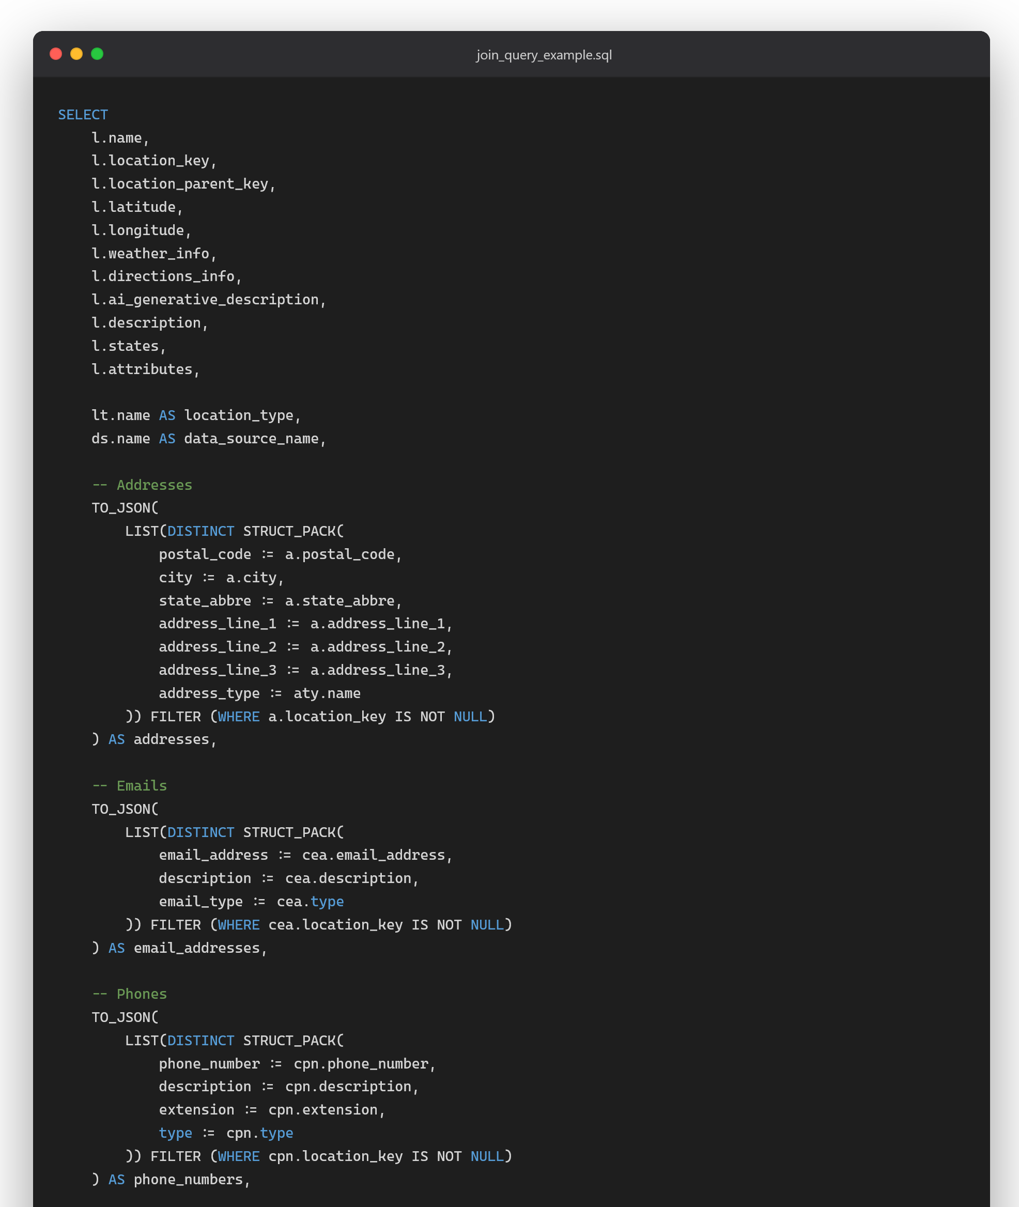
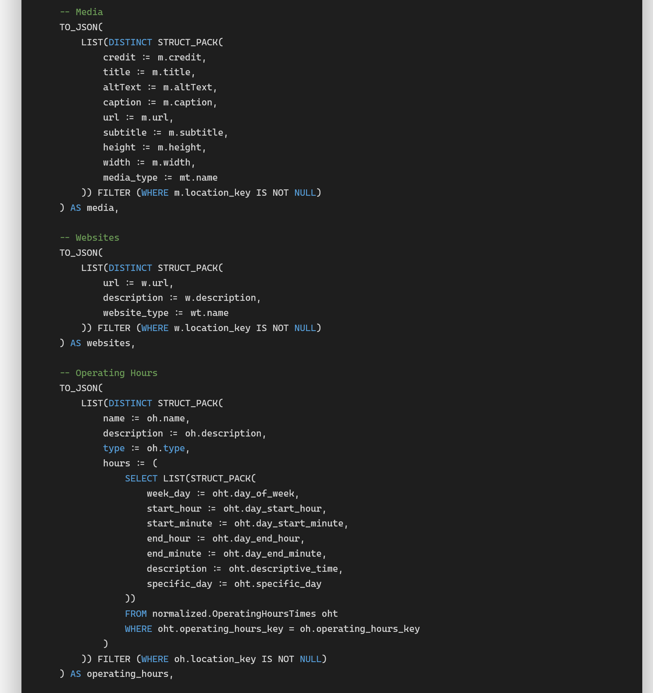
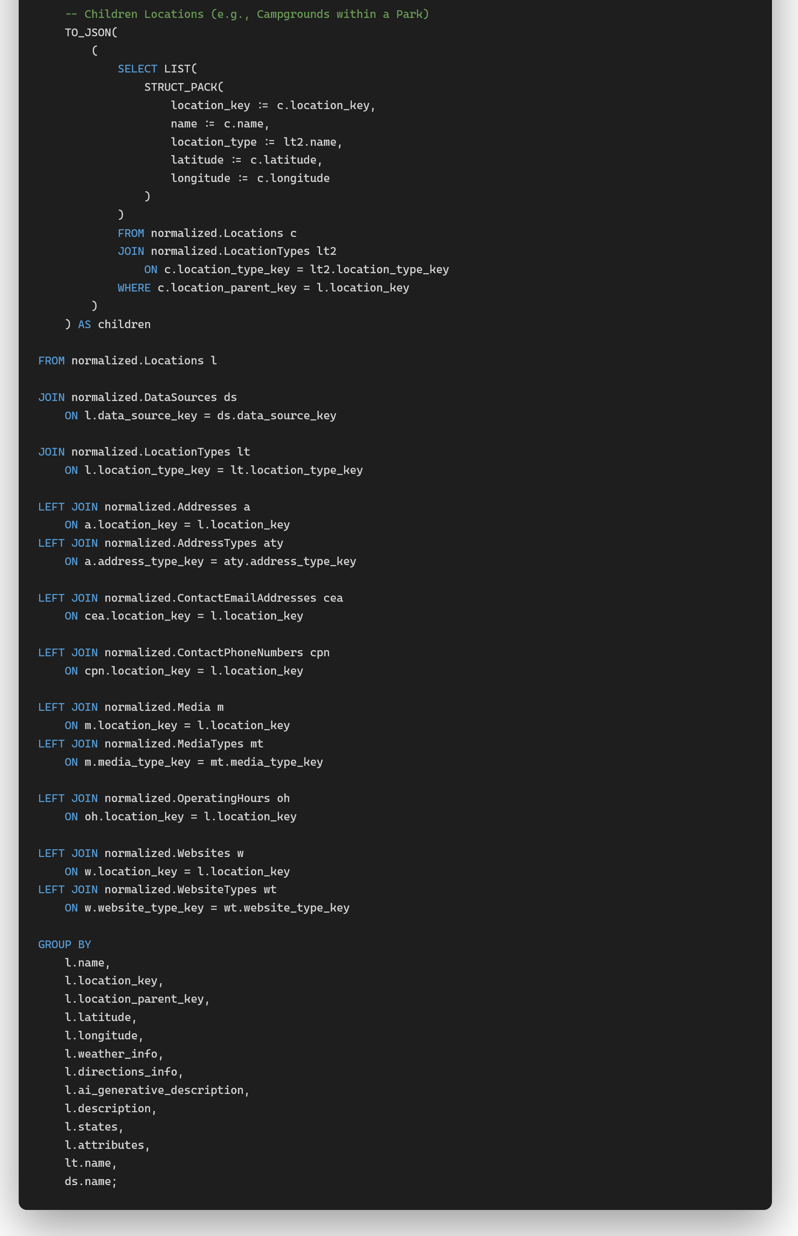

Transactions – Transactional Safety Built in & ACID
Textbook Reference: Chapter 17; Transaction Management

Transactions
I mainly utilized transactional safety when working on running the INSERT queries from the data source tables into the final normalized schema. While doing this one thing that I wanted to keep track of and manage is only to update the normalized namespace tables if the entire migrations script succeeds. To achieve this, I created an individual SQL script file for each source and wrapped all the migration logic (aka the INSERT queries) in a single transaction using BEGIN TRANSACTION and COMMIT. This allows all INSERT statements to be executed within one transaction block, and if any step fails during execution, the transaction is not committed, the transaction is automatically rolled back and none of the data that was being transferred during the transaction makes it into any of the normalized namespace tables. This approach guarantees no partial data ever makes it into any of the tables and I don’t have worry about data duplication or remnant data existing from a previous data transformation/migration attempt.

ACID Compliance
ACID is an acronym that represents four guarantees of reliable database transactions which are Atomicity, Consistency, Isolation, and Durability. Atomicity simply ensures an “all or nothing” result, meaning that if any part of the transaction fails, none of it is applied to the database. The next guarantee is consistency, which ensures that the database will be in a valid state before and after the transaction executes with all constraints, relationships, and rules remaining satisfied. Isolation ensures that transactions that are running at the same time do not interfere with one another, thus preventing intermediate or partial states from being visible to another transaction while one is running. The final guarantee is durability which ensures that once a transaction is committed, its changes remain, even if the system crashes shortly after the transaction completes.
Using an ACID compliant database is an important consideration for this project, especially during the data transformation process when data is being migrated from the source tables to the normalized schema. By placing all the INSERT SQL statements within a transactional boundary, I ensured atomicity where either all the data was successfully migrated, or none of it is. This prevented partial writes to the database that would have made additional work reset the database before trying the migration process again while also reinforcing overall data integrity.
It is also worth noting that both DuckDB and PostgreSQL are ACID compliant databases, but they are optimized for different use cases. DuckDB on one hand is designed for OLAP (analytical) workloads, making it well suited for data transformation and processing tasks. PostgreSQL on the other hand is optimized for OLTP (transactional) workloads and supports high concurrency, making it more optimized for serving data in an application environment. In this project, DuckDB was used to transform and prepare data for application use, while PostgreSQL is intended to serve it. PostgreSQL also outshines DuckDB based on its optimization for high-concurrent workloads that can scale based on application usage (Kutz).
Discovering

What I Learned
I learned a lot from this project. First, I learned about DuckDB as a piece of technology mainly used for analytical purposes. Working with DuckDB was quick to set up, easy to interact with, and interesting to use when properly uploading and managing data from multiple different sources.
I also believe I strengthened my SQL querying skills throughout this project. Although it will still take time to learn all the different syntactical differences between the ‘flavors’ of SQL I will encounter at work and in personal projects, I believe I have strengthened my understanding of how database technology can be used to effectively manage data more efficiently than any spreadsheet ever could.
A third concept that I was able to develop throughout this project was the ability to structure an ER diagram and code it into actual SQL without relying on AI or the Data Modeler tool to generate it for me. There were limitations within DuckDB that I had to overcome, such as the absence of an out-of-the-box solution for an auto incrementing primary key constraint and the lack of trigger support – both in which exist in other database systems such as Oracle and Microsoft SQL. These limitations, although surprising to me, forced me to find different ways to ensure data integrity and validity.

What Didn’t Work or Wasn’t Completed
Although I learned a lot, I also discovered limitations that, as of writing this, have not allowed me to complete the API and frontend layers of this project.
First, not all data sources are equally complete. The NPS data source is the most comprehensive. However, the MN DNR and MN GIS data sources are only partial, and there is meaningful overlap between them that ideally would be merged. The next step for this project after the semester would be to create a process that analyzes locations by their latitude and longitude proximity and estimates which locations should be merged, made parent-child relationships, or treated as distinct entities.
Second, it was difficult to properly assign locations as children of other parent locations without being able to visually see how they were positioned geographically on a map. For instance, NPS campground data is well-structured enough to allow campgrounds to be assigned as children of their parent national park locations. The same was not as straightforward with Google Places or MN GIS data.
Third, the non-completion of the optimistic goal — migrating data to PostgreSQL and building the API and frontend layers — was due to the minimum viable project turning out to be more involved than originally thought. Writing and validating the SQL transformation scripts with views and INSERT queries took additional time to complete.
Limitations

Incomplete Data Sources
The first limitation is that several data sources are not entirely complete. The RIDB and NPS data sources are the most comprehensive. However, the MN DNR and MN GIS sources are far from complete and likely contain overlapping location references to the same physical places. The next step will be to create a scripted process that analyzes locations via their latitude and longitude proximity and estimates which should be merged, which should become parent-child relationships, and which are genuinely distinct locations.

Geographic Scope
This project is currently limited to Minnesota state parks and US national parks. A more powerful and broadly useful project would attempt to collect and manage data spanning the entire United States. Expanding the scope would require additional data sources and more robust normalization work across a wider variety of source formats.

Optimistic Goal Not Completed
The PostgreSQL migration, Django API, and React frontend were not completed within the scope of this semester. The minimum viable project took more time than originally estimated, leaving insufficient time for the full-stack layers. These remain planned next steps for the project beyond this class.

Ethical Considerations
Working on this project raised a few ethical considerations worth noting:
- Data Licensing and Public Availability: Most data collected for this project comes from state and federal government websites, which are generally considered publicly available. However, before publishing this project or its data publicly, I would need to confirm that the specific datasets used can be legally redistributed on a personally managed website, particularly the Google Places API data, which has specific terms of service around caching and redistribution. Especially around the photos users publish on their platform.
- Data Accuracy and Currency: Without a regular automated pipeline to re-retrieve and compare data against current collected data, I cannot guarantee that the information remains accurate over time. Any published version of the Explore More project would need to clearly communicate to users when the data was last verified.
- Third-Party Image Rights: If I want to display media associated with park locations that come through the Google Places API, I would need to continue using the Google API and paying for its usage rather than downloading and re-hosting those images on my own media server, as doing otherwise would likely violate Google’s terms of service.
- Web Scraping Considerations: If the project is extended by scraping additional sources such as Wikipedia, state websites, or third-party park information sites, I would need to review each source’s terms of service and robots.txt to ensure compliance before doing so.

Conclusion
Although this project’s optimistic goals weren’t entirely complete as of writing this document, the foundation that has been built is one I’m proud of and plan to continue working on after the conclusion of this class. Working through this project has reinforced that building something meaningful with data requires more than just knowing the SQL or Python syntax. Rather it requires understanding the concepts well enough to make deliberate design decisions, like choosing how to model a self-referencing hierarchy, identification of different entities and the relationships between them, when to use a view versus a Python script or how to structure a transaction so that failures are recoverable. DuckDB proved to be an interesting and powerful tool for this kind of data management and transformation project, and this project gave me a real-world context to apply nearly everything covered in this course. Ultimately, what started as a side project I wanted to build for myself – a better way to access information about Minnesota’s parks, forests and campgrounds – has become something I now have a much stronger foundation to continue working on and eventually finish. Thank you for reading.

Works Cited
“6 Best Open Source Geodatabase Solutions to Explore.” maplibrary.org, Map Library, https://www.maplibrary.org/10579/6-best-open-source-geodatabase-solutions-to-explore/. Accessed 24 April 2026.
“DuckDB vs PostgreSQL: What’s Better for Data Analysis in 2025?.” digitalogy.co, Digitalogy, 13 May 2025, https://www.digitalogy.co/blog/duckdb-vs-postgresql/. Accessed 21 April 2026.
Kutz, Jim. “DuckDB vs Postgres - Key Differences.” Airbyte.com, Airbyte, 1 Sept. 2025, https://airbyte.com/data-engineering-resources/duckdb-vs-postgres. Accessed 21 April 2026.
Matson, Jacob and Aditya Somani. “PostgreSQL and Ducks: The Perfect Analytical Pairing” motherduck.com, MotherDuck, 16 June 2025, https://motherduck.com/blog/postgres-duckdb-options/. Accessed 21 April 2026.
Mannino, Michael. “Database Design, Query, Formulation, and Administration”. 8th ed., Chicago Business Press, 2022.
Rolli, Daniel. “Tales of a Salesforce Migration: Challenges and Pitfalls to Avoid.” salesforceben.com, Salesforce Ben, 14 March 2025, https://www.salesforceben.com/tales-of-a-salesforce-migration-challenges-and-pitfalls-to-avoid/. Accessed 22 April 2026.
“Schema.” motherduck.com, MotherDuck Glossary, https://motherduck.com/glossary/schema/. Accessed 21 April 2026.
“Spatial Extension.” duckdb.org, DuckDB Docs, https://duckdb.org/docs/current/core_extensions/spatial/overview. Accessed 26 April 2026.
“Top 5 Spatial Databases for GIS Professionals in 2025.” Geodata Insights, https://geodatainsights.com/top-5-spatial-databases-for-gis-professionals-in-2025/. Accessed 24 April 2026.
Veeraraghavan, Anantharaman. “Common Challenges In Salesforce Data Migration.” minisculetechnologies.com, Minuscule Technologies, https://www.minusculetechnologies.com/blogs/salesforce-data-migration-challenges. Accessed 22 April 2026.
Resources
ChatGPT Discussion: https://chatgpt.com/share/69f68ab8-c35c-83ea-8c44-318dc10a8f30
DuckDB Repository: https://github.com/duckdb/duckdb
DuckDB Documentation: https://duckdb.org
GitHub Repository where project is managed: https://github.com/Tuck1297/University-of-St.-Thomas-Graduate-Projects/tree/main/GIS-Data-Migration-Project
PostgreSQL Documentation: https://www.postgresql.org

